Case Study

Q1.

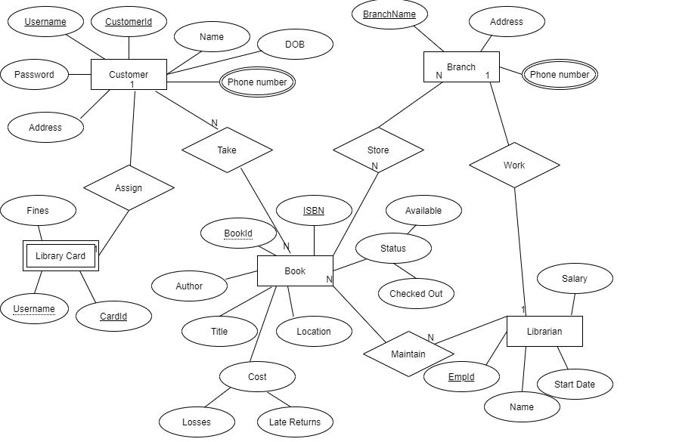

ER Diagram

Q2.

Books – Books are taken by customers. Books are maintained by librarians. Books are stored in branches.

Customer – Customers take books to read. Each customer has a library card.

Branch - Branches store books. Each branch has one librarian.

Librarian – librarian maintains books. Each librarian works at one branch.

Library cards – library cards are issued to customers.

1

Q3.

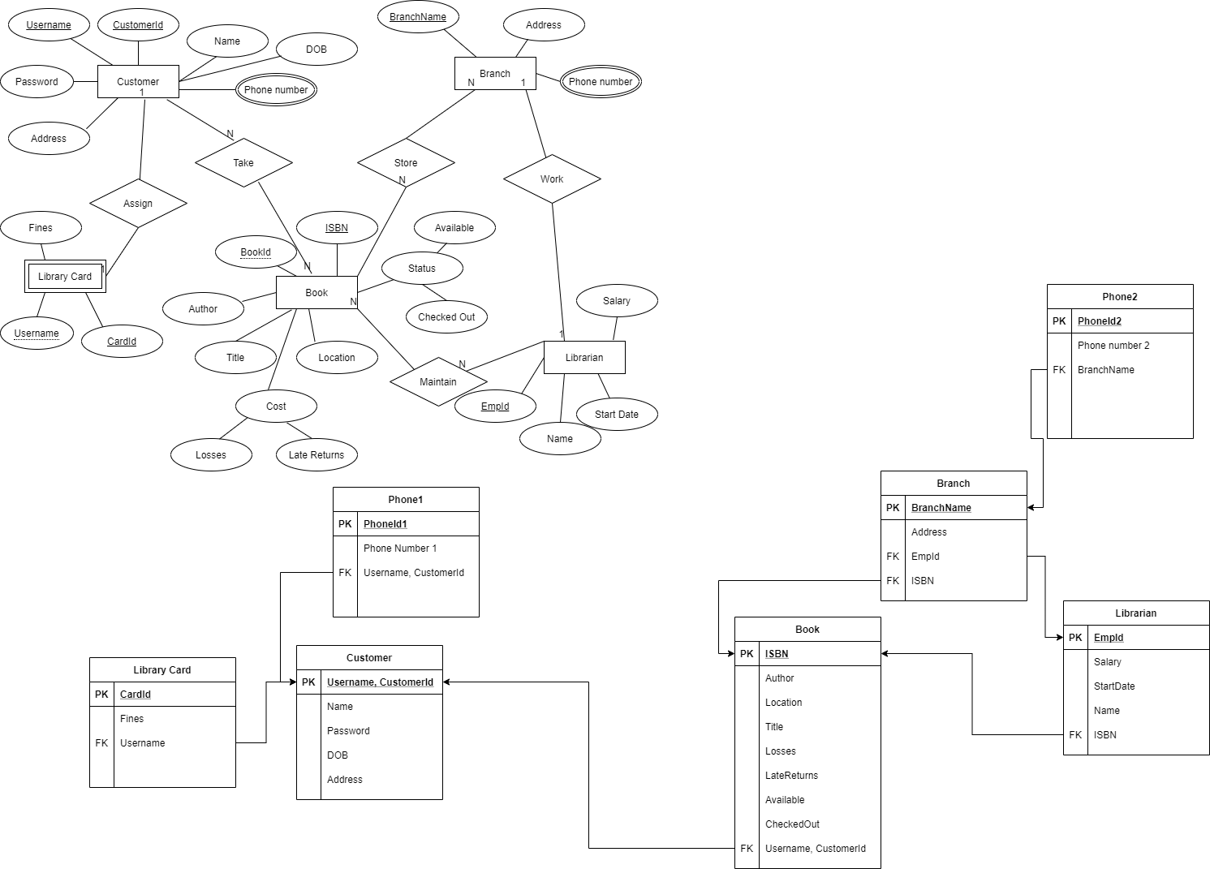

Relational model

Book – **ISBN,** author, location, title, losses, late returns, available, checked out, Username, CustomerId

Customer – **Username, CustomerId,** name, password, dob, address

Librarian – **EmpId,** name, salary, start date, ISBN

Branch – **BranchName,** address, EmpId

Phone1 – **PhoneId1,** phone number1, Username, CustomerId

Phone2 – **PhoneId2,** phone number2, BranchName

Library card – **CardId,** Username, fines

2

Q4.

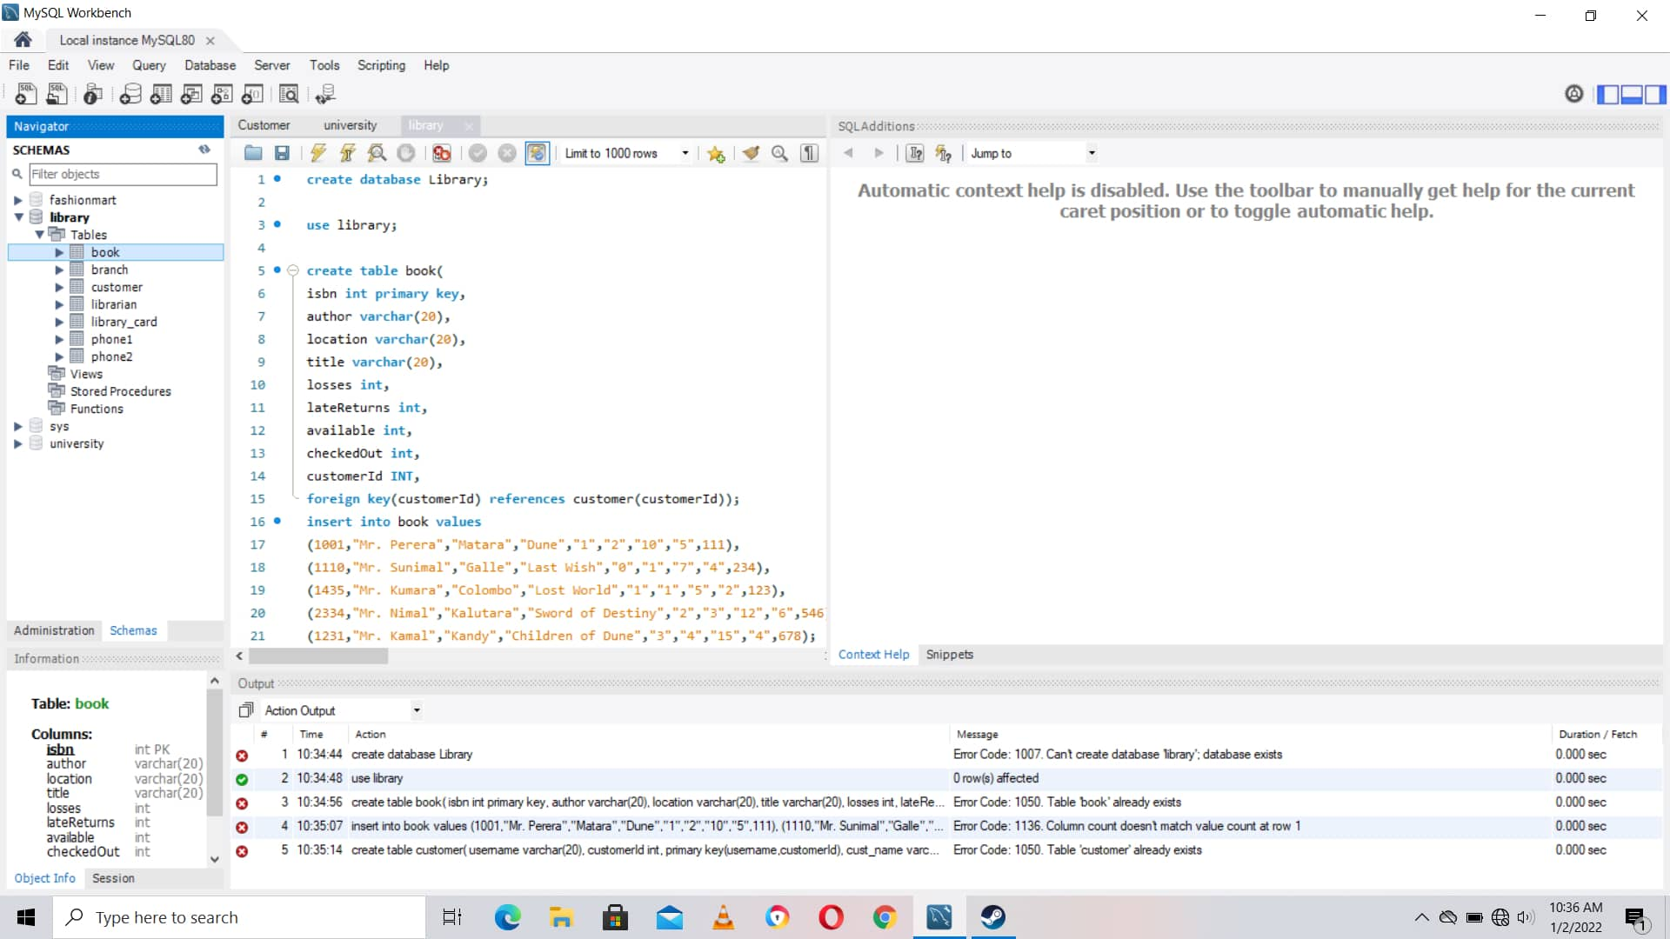

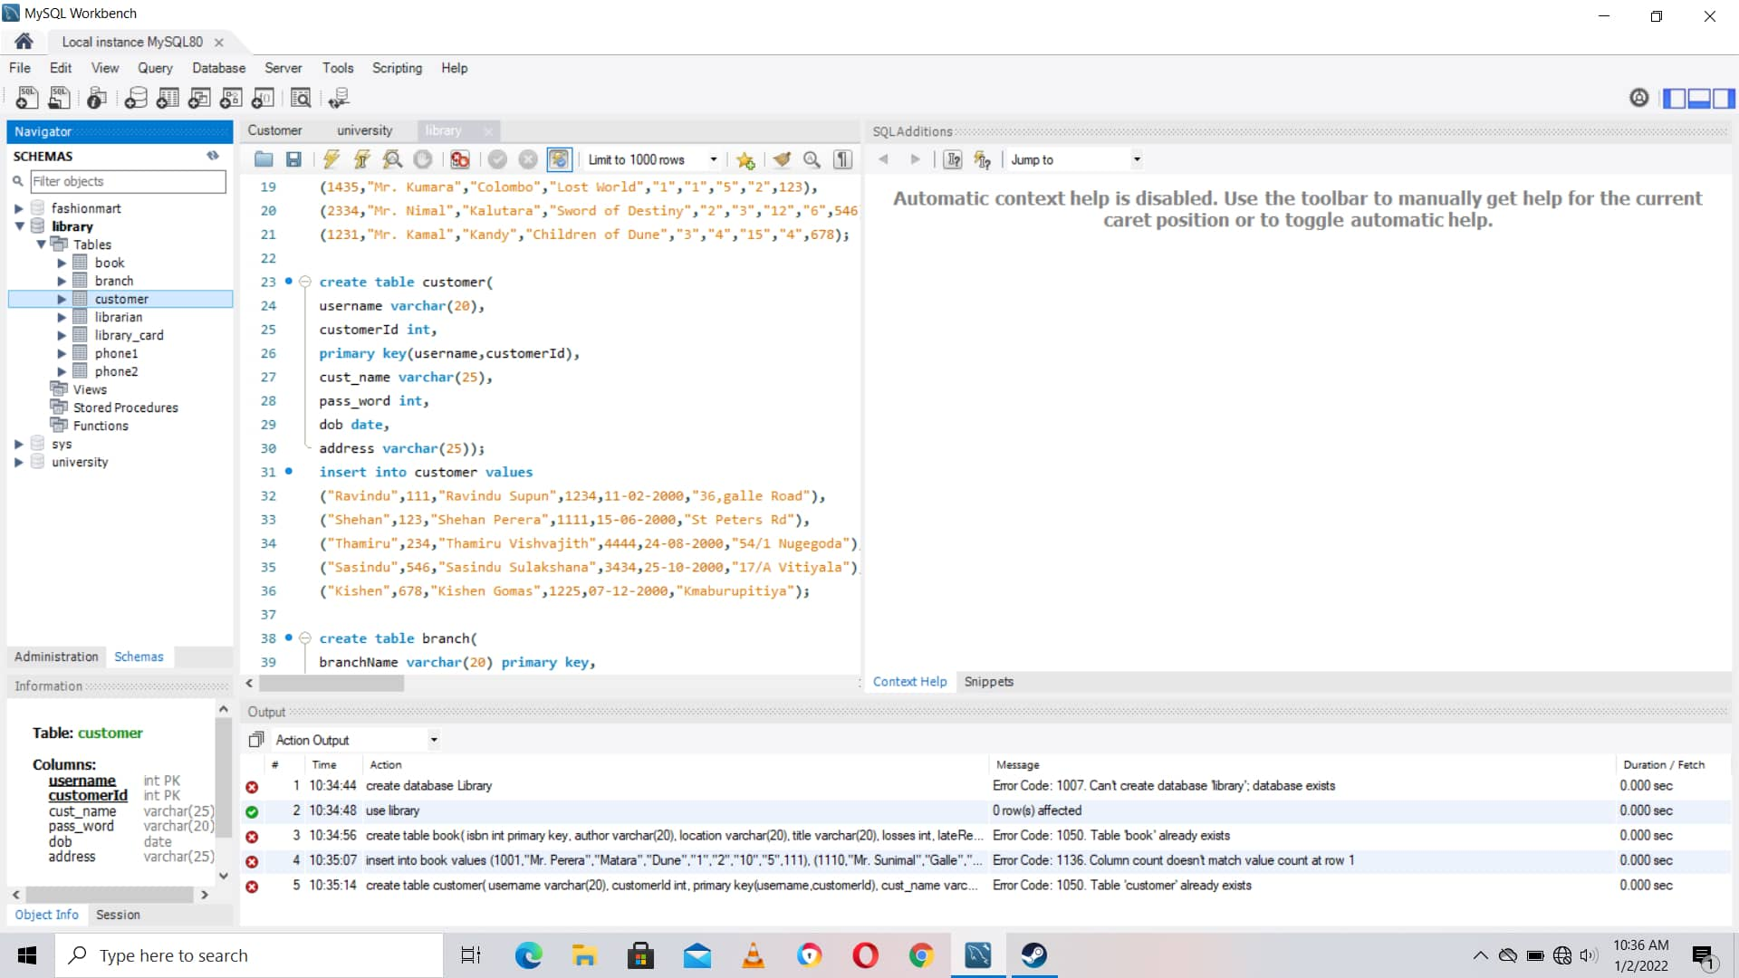

3

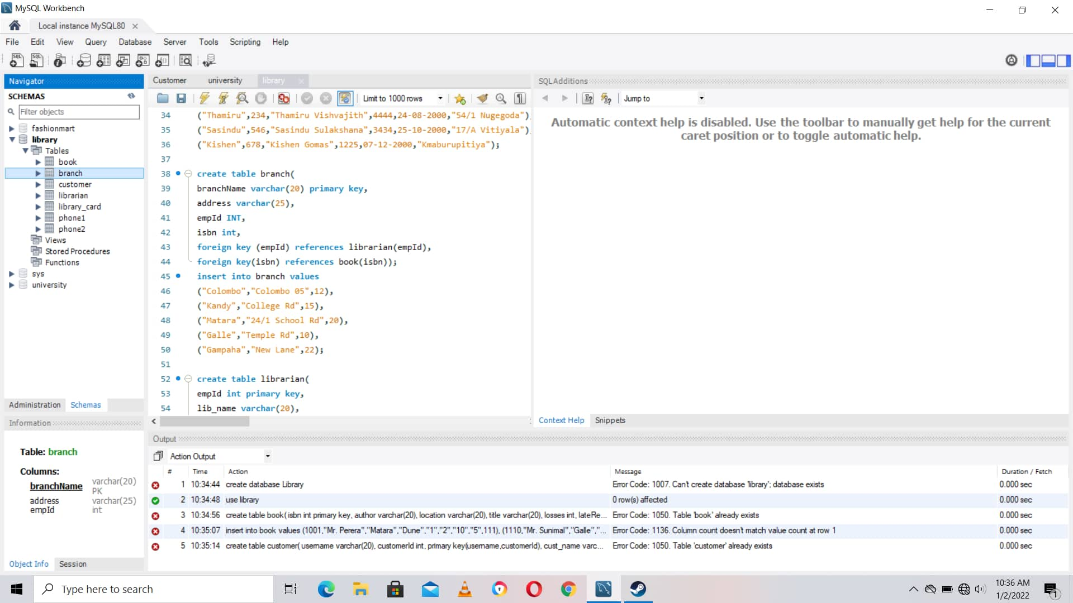

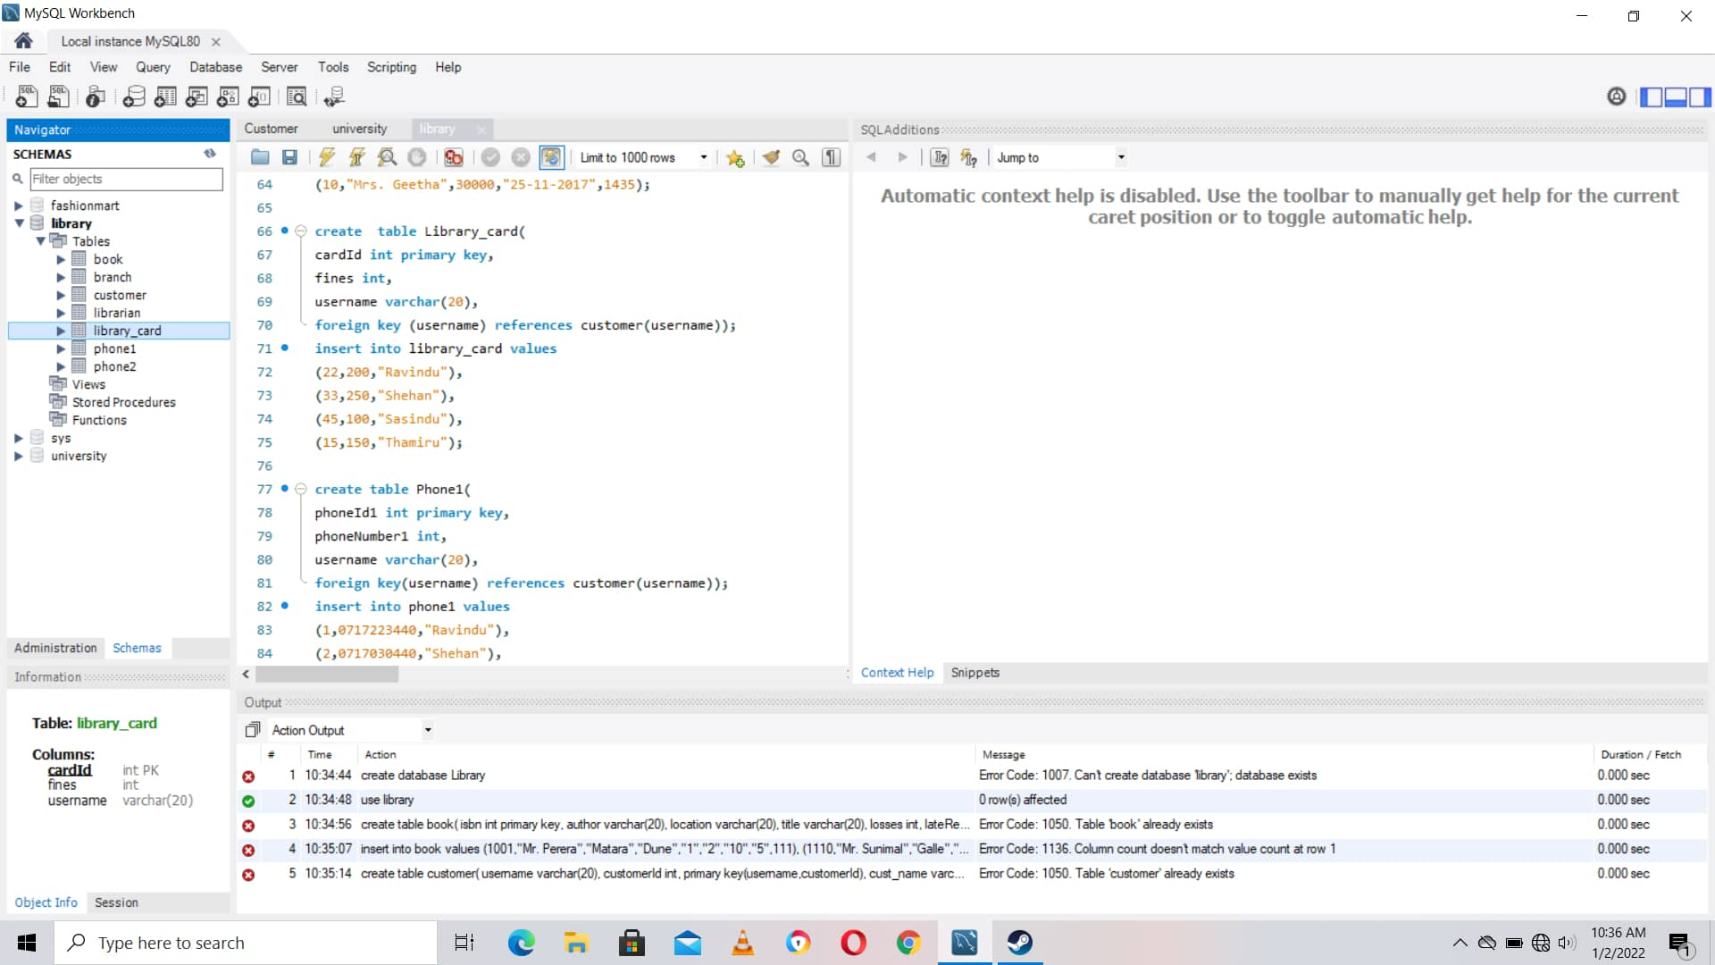

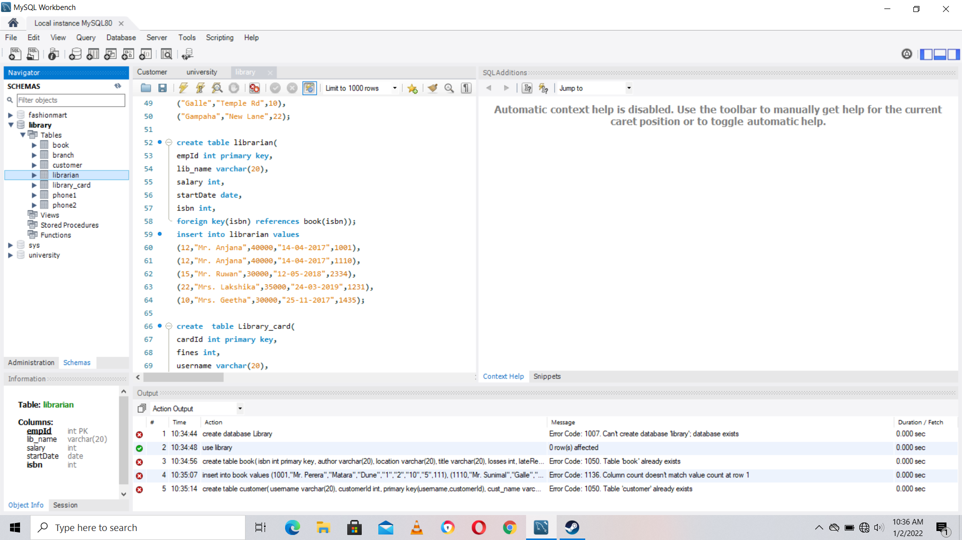

4

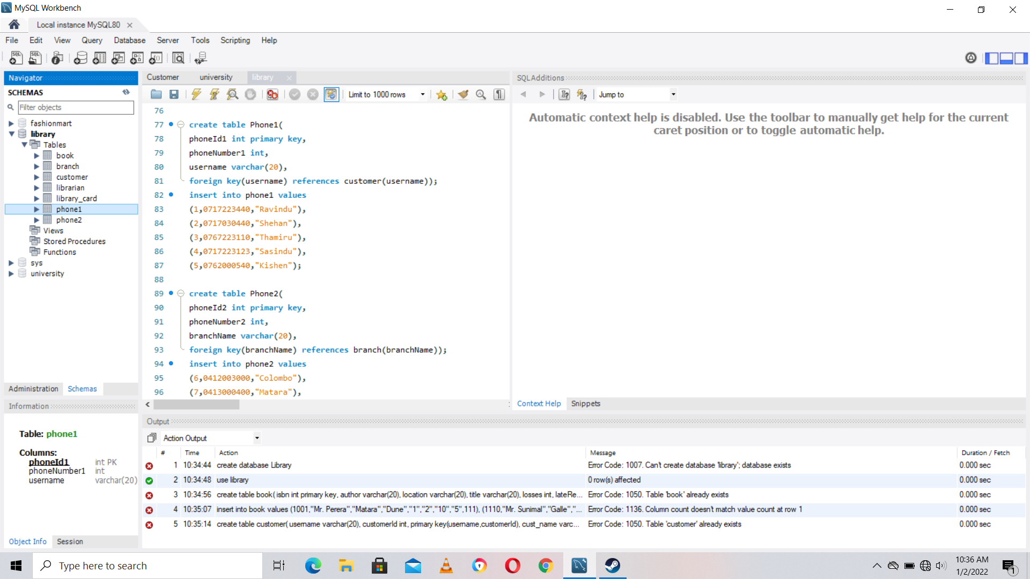

Q5.

1.

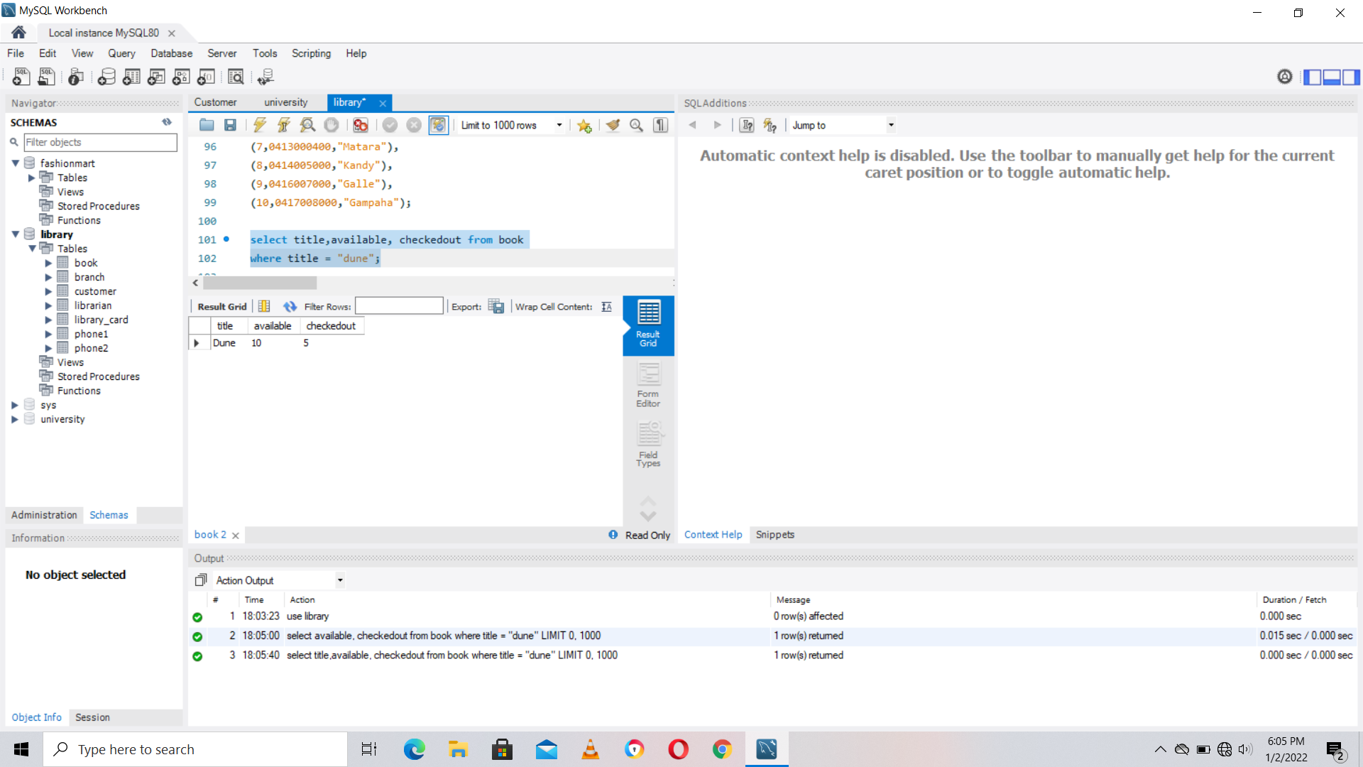

5

2.

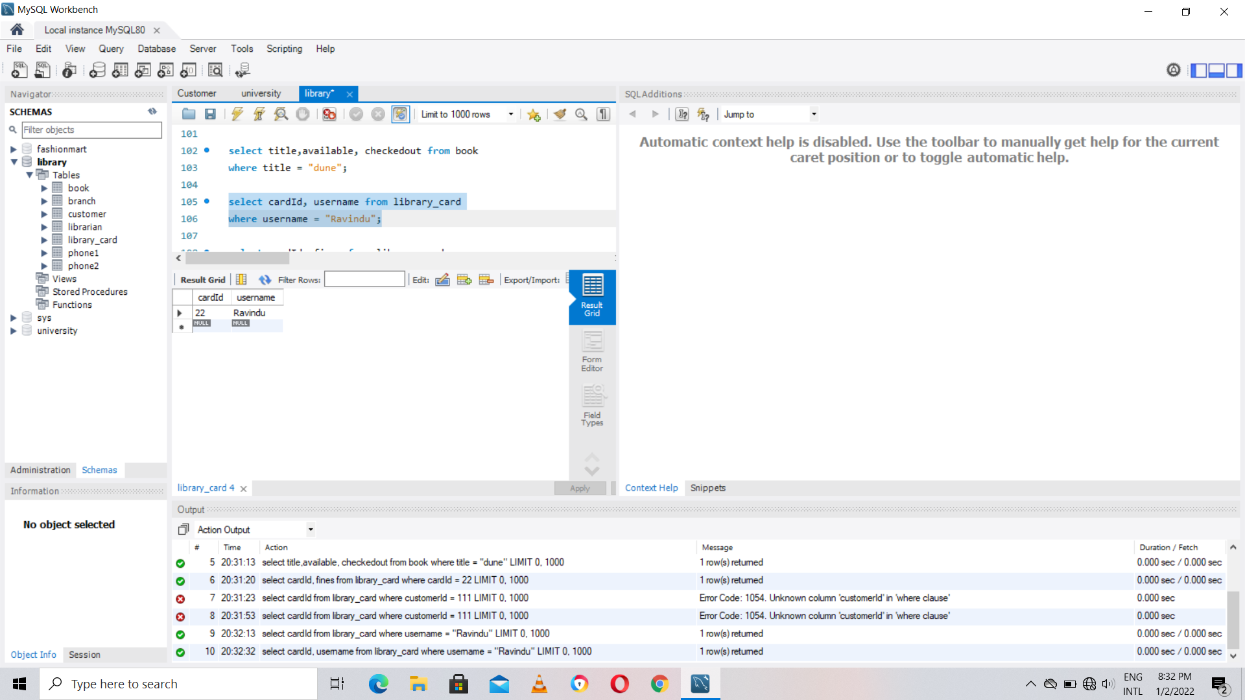

3.

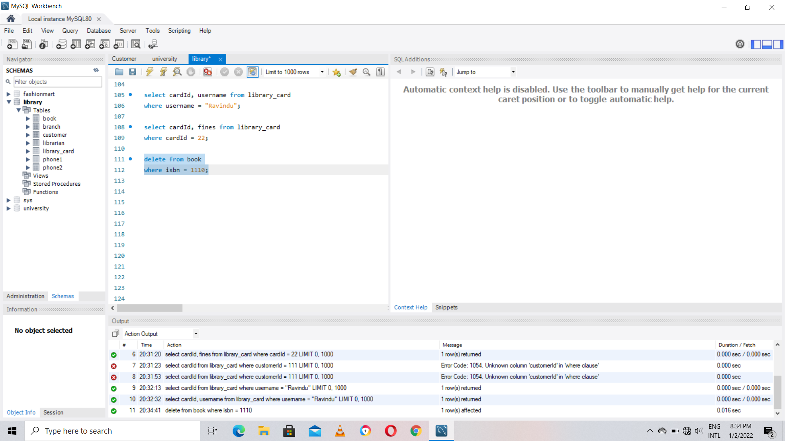

6

4.

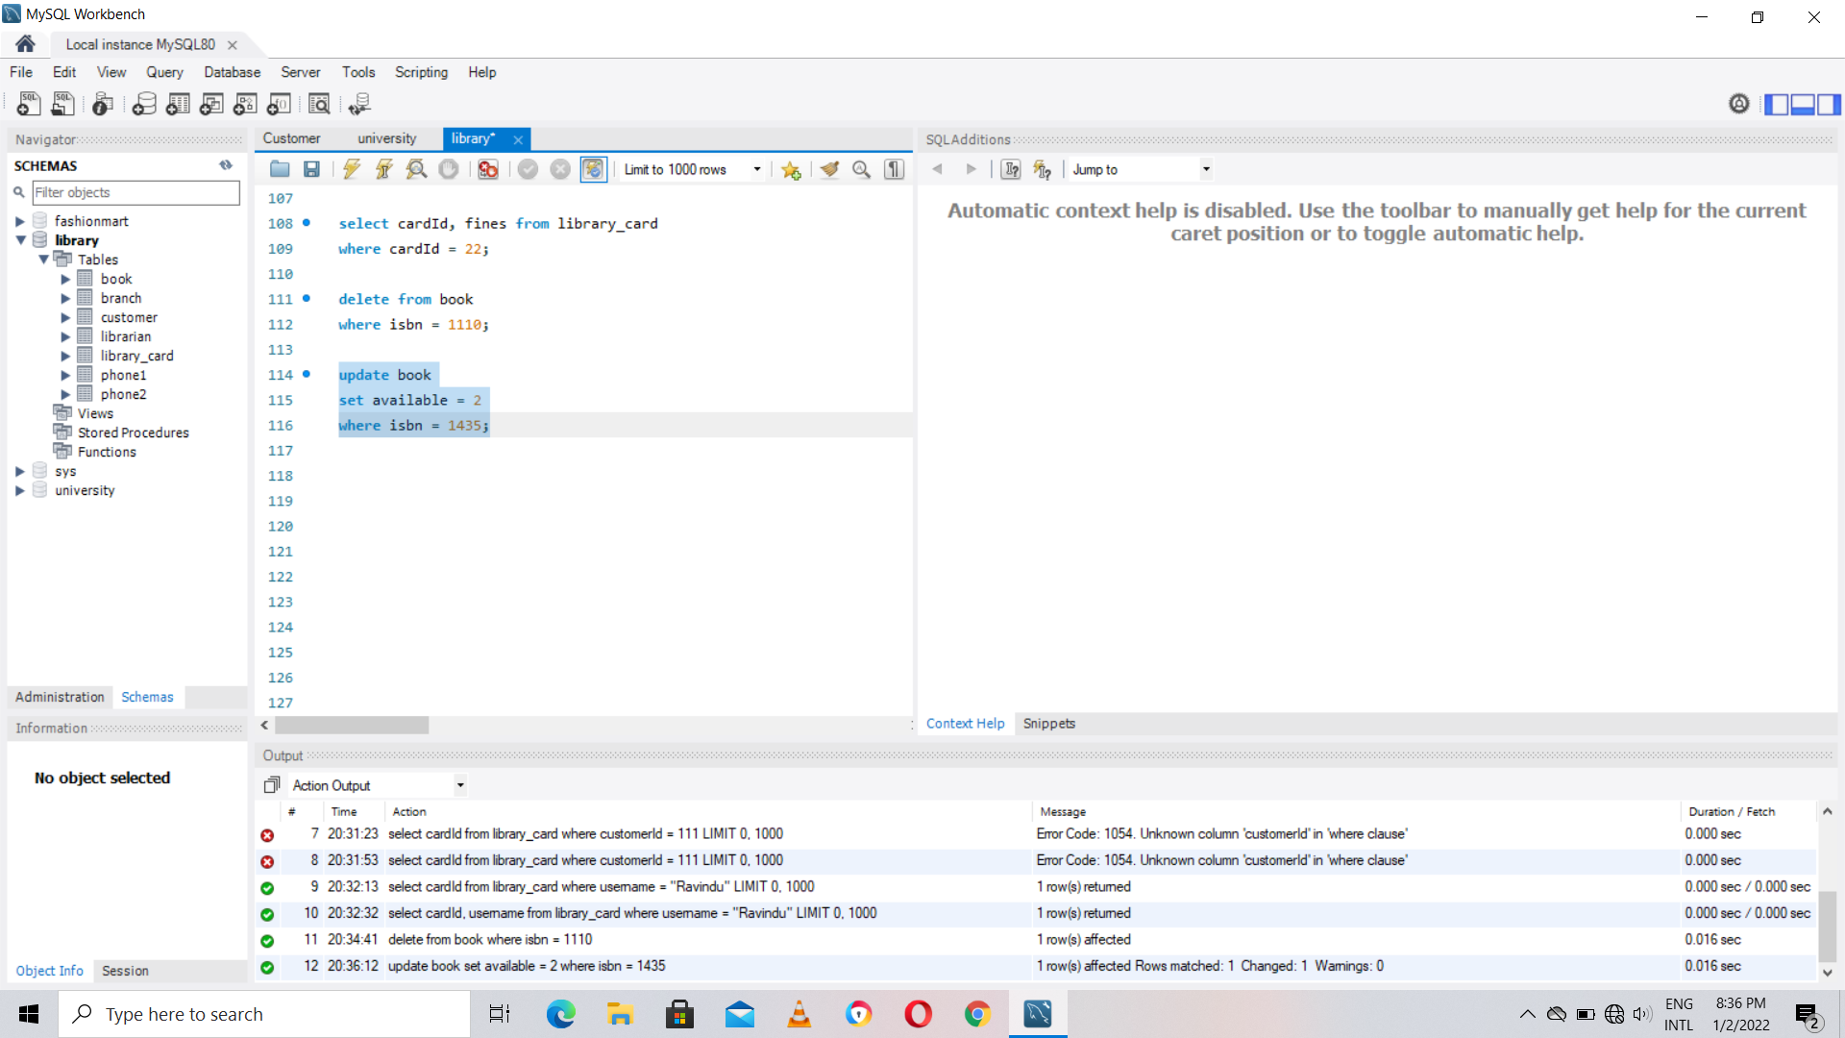

5.

